Thomas Hirschhorn. The Purple Line

curated by Hou Hanru, Luigia Lonardelli

20 October 2021 - 6 March 2022

MAXXI | Gallery 3

www.maxxi.art

Press kit maxxi.art/area-riservata/ password areariservatamaxxi

«The world needs to be de-pixelated»
Thomas Hirschhorn
Rome, 19 October 2021. An imposing 6-metre-high, more than 250-metre-long purple wall crosses MAXXI's Gallery 3, cutting through the sinuous spaces of the museum designed by Zaha Hadid, imprisoning the viewer and leaving the eye dazed: it’s The Purple Line, the long line conceived by Thomas Hirschhorn, one of the world's most famous and important artists, to present Pixel-Collage, a monumental series of 121 works produced between 2015 and 2017.
118 of these collages from 21 prestigious international private collections, institutions and galleries will be on display at MAXXI, thereby marking the first time that almost all collages are featured together in an exhibition.
Thomas Hirschhorn. The Purple Line, curated by Hou Hanru and Luigia Lonardelli, will be open from 20 October 2021 to 6 March 2022.

Pixel-Collage:
«I’ve always loved making collages. I love bringing together what shouldn’t be brought together».
In these works, which are among the most interrogating on the scene, images of mutilated bodies in war zones and snapshots of massacres and conflicts collected on the web are juxtaposed with fashion advertising pictures from trendy magazines using the collage technique.
However, the latter are pixelated, while the photos of destroyed bodies are visible, unfiltered, often in large formats.
This reverses what usually happens in everyday life, in the media, on the web and in social networks: advertising pictures designed to capture attention are hidden from view, while what is normally obscured and concealed as disturbing is revealed by the artist in all its raw truth.
The Pixel becomes a tool that connects and creates links between things, as well as between beauty and cruelty, and shortens the distance between two apparently opposing realities that are nevertheless contemporary in our age, which is riddled with contradictions, «chaotic, complex, cruel, incommensurable, beautiful».
«I want to express the complexity and contradiction of the world into a single collage. I want to express the world that I am living in, not the whole world as the entire world but as a fragmented world. My collages are a commitment to the universality of the world. I am against particularism, against information, against communication, against facts and against opinion».

Hypersensitivity and censorship:
In the words of Hirschhorn, «Putting or removing each pixel - or even cutting it into smaller pixel parts - is a decision. It’s a political decision».
At first glance, the violence of the subjects represented in the Pixel-Collage series appears to be the central and predominant theme of this work, which instead focuses on censorship, the production and control of images and, above all, a concept expressed several times by the artist, namely the spread of hypersensitivity in the contemporary world.
Hirschhorn distinguishes between the sensitivity of an observer who remains vigilant and aware of their surroundings without denying them, and hypersensitivity, which is instead self-protection, numbness, exclusion of the other and often leads to censorship.
While the use of pixels is designed to protect the viewer, the artist rejects any kind of protective intervention; while what has no form is blurred and invisible and does not enable us to feel empathy, Hirschhorn seeks the truth and visibility.
«Today, in the newspapers, magazines and TV news, we very seldom see images of destroyed bodies because they are very rarely shown. These pictures are non visible and invisible: the presumption is that they will hurt the viewer’s sensitivity or only satisfy voyeurism, and the pretext is to protect us from this threat. But the invisibility is not innocent. The invisibility is the strategy of supporting, or at least not discouraging, the war effort. It’s about making war acceptable and its effects commensurable. […] To look at images of destroyed human bodies is a way to engage against war and against its justification and propaganda».

The Purple Line:
The line on the wall on which the works are exhibited at MAXXI, which was specially designed by the artist, forces those navigating the space to face their limits, pushes the envelope of what sight and perception can bear, and keeps attention high.
The constant changes of direction make it impossible to predict where the apparently endless path will end; the images reach the viewer's eyes without warning, and the ability to filter them is nullified, as is the possibility of being protected.
The expression ‘The Purple Line’ refers to colour theory: indeed, it refers to a precise point between the red and violet spectrums that corresponds to the maximum saturation of these two colours, where the intensity of the light appears in a single wavelength. This results in what is known as «pure color», which is both vibrant and disturbing to look at, attractive and repelling, and extreme with regard to its impact on perception.
While the natural reaction in the face of death, blood and fear is to look away, purple forces us not to be distracted, to face what frightens us, to return our eyes to the collages, to observe reality and understand its contradictions.
«Today, more than ever, I need to see everything with my own eyes in our one world, and no one can tell me what my eyes should see or not».

Catalogue:
The catalogue and the free magazine distributed in the exhibition have been conceived by Thomas Hirschhorn with the help of Romain Lopez.
The catalogue, which documents the artist’s research on Pixel-Collage, includes an anthology of writings by Hirschhorn and an unpublished text he wrote for MAXXI, as well as essays by the curators Hou Hanru and Luigia Lonardelli, and international art historians and curators such as Lisa Lee, Associate Professor of Art History – Emory University, Atlanta; Nataša Petrešin Bachelez, Head of Cultural Programme – Cité internationale des arts, Paris; Yasmil Raymond, Rector – Hochschule für Bildende Künste-Städelschule, Frankfurt; and Dirk Snauwaert, Founder and Artistic Director – WIELS, Brussels.
The Showcase for Thoughts section, which corresponds to a similar part of the exhibition, is particularly interesting. It presents the artist's research materials, art references, advertising and press images, books and short texts.
A rich iconographic apparatus accompanies the volume, from views of the installations to the images collected in the Catalog Raisonné, an exhaustive documentation of Pixel-Collage.

Public program:
During the exhibition period, thinkers, philosophers and sociologists will be invited to reflect on the theme of the spread and control of images on the web and the phenomenon of pixelation as censorship of content considered offensive. The first events will be a talk with Thomas Hirschhorn and one with curators Hou Hanru and Luigia Lonardelli (21 October at 6 pm).
These talks will be followed by in-depth discussions with Bianca Berlinguer and Valentina Petrini (3 November); Maurizio Ferraris (12 November); Luca De Biase and Donatella Sciuto (16 December); Maura Gancitano and Riccardo Luna (14 January); Lucia Goracci and Massimo Polidoro (26 January); Vittoria Martini e Stefano Velotti (9 February). All information can be found at maxxi.art

Videogallery:
On the occasion of the exhibition, the Museum's videogallery will feature a selection of talks given by Thomas Hirschhorn on the Pixel-Collage series: three conversations with international curators and critics that trace the genesis, history and meanings of this important cycle of works, which the public will be able to see in its entirety for the first time at MAXXI.
The videogallery programme will be opened by the 2016 talk with curator Nataša Petrešin-Bachelez, followed by the talk with one of America's leading art critics, Hal Foster, and the conversation with Hou Hanru and Luigia Lonardelli that will take place on 21 October 2021.

“Thomas Hirschhorn. The Purple Line” has been produced with the support of Institut Français, Swiss Institute in Italy, French Academy in Rome-Villa Medici, Fondazione Nuovi Mecenati, Pro Helvetia Swiss Cultural Foundation, Alfonso Artiaco Gallery, Galerie Chantal Crousel, Dvir Gallery, Gladstone Gallery.

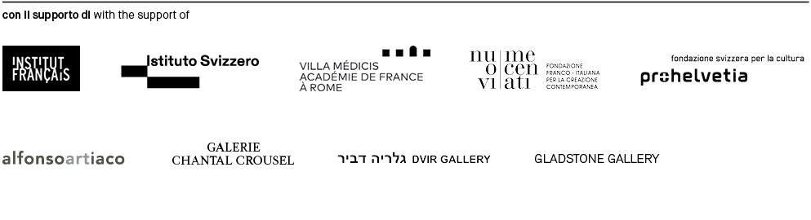
MAXXI PRESS OFFICE +39 06 324861 press@fondazionemaxxi.it

